**Determining a measure of eye precision using the Unity SRanipal API**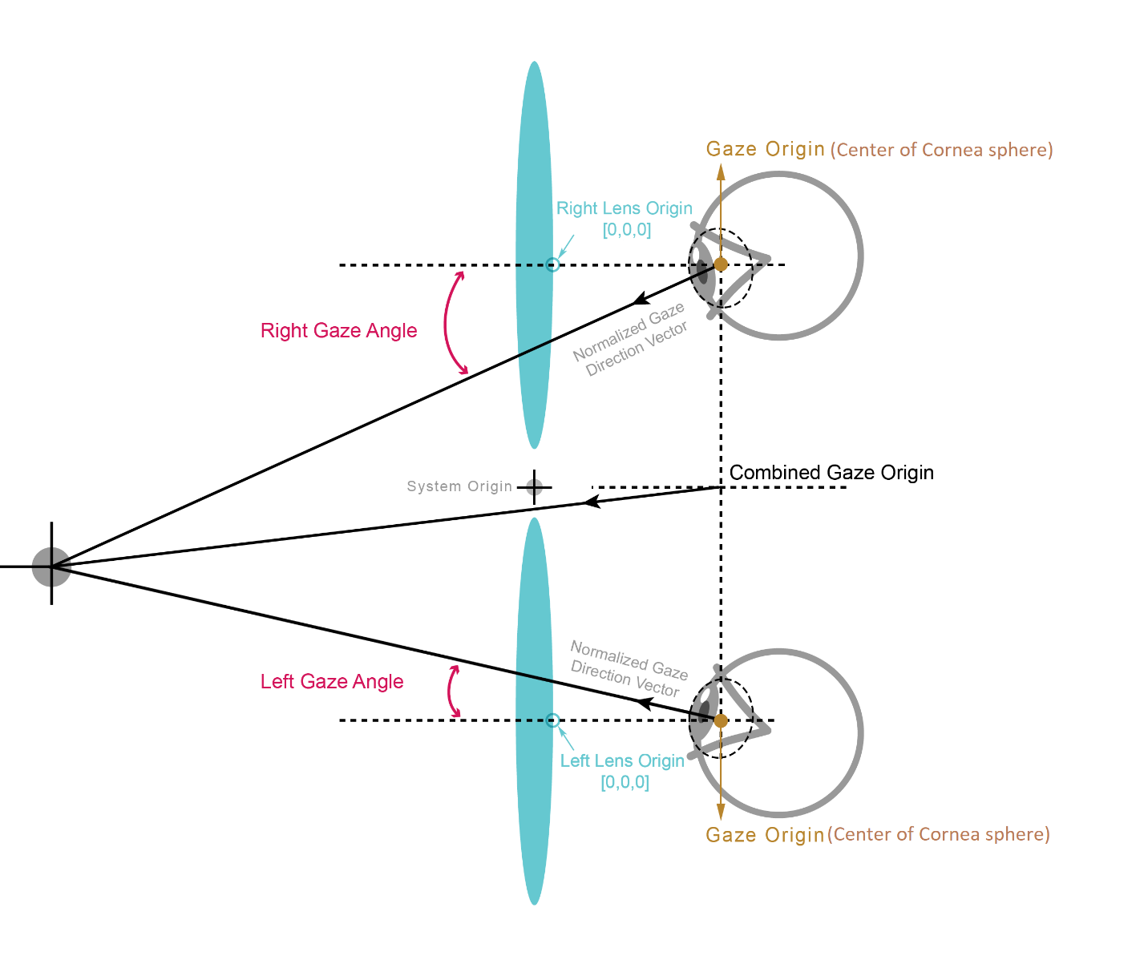

To determine precision, two vectors are needed with an identical origin:

1. The gaze direction vector pictured above, with originates at the gaze origin
2. The vector from the gaze origin to a target object of which we are measuring precision to.

Once these vectors are collected, calculating precision is a simple matter of:

1. Taking the angle between these two vectors, which will return a value from 0 to 180, with 0 representing perfect precision (equal vectors) and 180 representing the worst possible precision (opposing vectors).
2. Dividing this value by 180 to normalize the value between 0 and 1.

**Collecting the vectors**

The 1st vector, gaze direction, is provided by the API.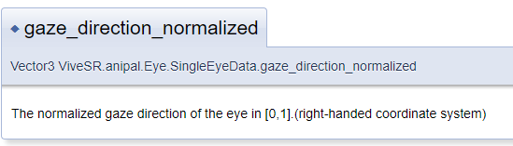

This vector originates from the gaze origin point vector, which is also provided by the API.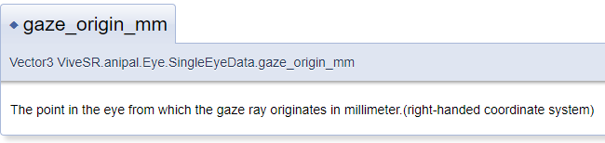

The 2nd vector must be calculated by taking the position vector of the target object in unity and subtracting the eye origin vector from it. According to the principles of Linear Algebra, this results in a vector representing the line from the origin to the target.

Unfortunately, it is unclear what this gaze origin is. The documentation fails to specify, but my own testing has shown that this value does not represent coordinates relative to Unity’s scene origin. It must be relative to some other origin point. I have reached out to developers and posted on the vive forums in hopes that I may get some information about this.